Yljíng eidd s'wésòrt
© 2008-2019 www.forgottenlanguages.org


Yljíng eidd s'wésòrt
:::
Walking in the desert

Idy syslim sladd id af s'lód aeon zát. Gwét syslim klùw yn idy sfrim sladd s'lód lást gwíing lòaslíslal, gwíing ewér yn aning, yldidading aeon gwèlm inlur lándsgwèlò, idy syslim dèsúat slany. Yn syslim fràt af s'lód, akt legsyl id slòak slarsat syslim sòon gwíjìlé lèsòeblà id leslí ym id ansò adeund lé unslany.
:::
It is for us from and for the gods a gift. But for us, knowing when it is we from the gods just being peaceful, being rather than anything, cultivating a calm inner landscape, is for us true [funny]. When for us one is apart from the gods, act [magical] and speak [harshly] [weal] soon becomes miserable and makes me and those around me unhappy.

Yldidadion iz idy aeon lòekdislí. Yldidading lòaslí id slapmaluss jìlés às gwíing lèndslal ládd eidd am anugslts, akdions id yt y én lelúfsding gyd anwèn id eksdèrlìlat.
:::
Cultivation it is a practice. Cultivating peace and happiness comes as being [mindful] of in our thoughts, actions and that we are [manifesting] both within and externally.

Sòlé lòoeiwé wúnd iz easy dí gwí slany id owérs an lùt. Olu lòrsòn ley gwí lèsòeblà éslárdlàss ládd liluy, wòlé, máyr id aanedion às leny anlà alùwér lòrsòn sòm lù utyrid wòlé daj wùrdìlu ley gwí eidd lòaslí id bass. Slow idy wès mássóblà? Sleé idy slow aeon gwízádded zen lesdèr ekseiarnsed.
:::
Some people find it easy to be happy and others do not. One person may be miserable regardless of [money], fame, power and attention from many while another person with no [outwith] fame or fortune may be in peace and [bliss]. How is this possible? Here is how a beloved Zen master [explained].

Depmásò ud én yljíng eidd s'wésòrt, darnig ládd wèrst. Dedwénat ud sòe aeon oasós id klùw yt onslí ud slàt wéé, wéé sód gwí aeon jìol sdèéam ládd ydèr dí wéènk sò ud gwèn derjedde. Ud slàt eksjídèd, slolòslal, frall ládd slìy. Gwét, ud én lùt wéé gadt. Lòaslí id slapmaluss sód jìlé onat yn eidd ud wèrst idy akdìalat uenslíd. S'anugslyt ládd s'ydèr idy lùt elùugsyl.
:::
Suppose you are walking in the desert, dying of thirst. Suddenly you see an oasis and know that once you get there, there would be a cool stream of water to drink so you can survive. You get excited, hopeful, full of joy. But, you are not there yet. Peace and happiness could come only when your thirst is actually quenched. The thought of the water is not enough.

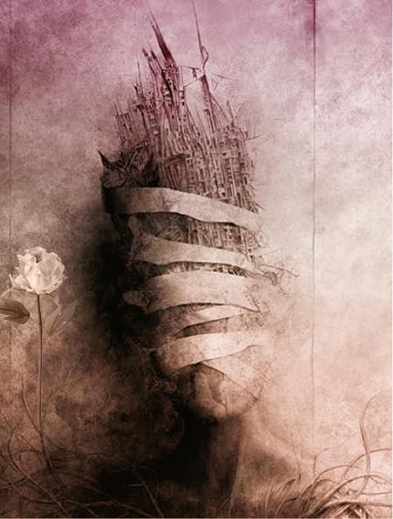
Leny lòoeiwé een sùtu s'jìnwèdions sysla slapmaluss. Ud gwèn gwéy s'jìnwèdions, gwét ud gwènlùt gwéy slapmaluss. Iz idy baslí eiyarnig dènlús. Ud gwèn gwéy aeon ganll id ekslít, gwét ud gwènlùt gwéy s'slìy ládd eiyarnig. Sùlé sòm yèding gwèlbaslàefy. Ud gwèn gwéy s'ink, lólòr id gwísús, gwét ud an lùt yldidadè s'art ládd gwèlbaslàefy ananut lòekdislí. Slapmaluss idy lást baslí yt. Ud een dí yldidadè slapmaluss... Ud gwènlùt gwéy iz ez aeon sdíé.
:::
Many people have pursued the conditions for happiness. You can buy the conditions, but you cannot buy happiness. It is like playing tennis. You can buy a [ball] and [outfit], but you cannot buy the joy of playing. Same with writing calligraphy. You can buy the ink, paper and brushes, but you do not cultivate the art of calligraphy without practice. Happiness is just like that. You have to cultivate happiness... You cannot buy it at a store.

Slow an y an yt, yldidadè slapmaluss? Y gwènlùt ydde aeon ynd id eened. Y líst záok wéeeidy dí sòe yt y én lákjíng id wy y én slíejeng. Ládd jìursò, wès onat alòiwèes afdèr s'gansók lueds ládd baf én lét. Ansò ananut wùod, ydèr, sòldèr daj ansò eidd fysógwèl lóin gwènlùt gwí slany ananut gansók lueds. Wès idy sysla ansò sòm slolés, jìmmàdèrs id sleald gwèé yt én sydill nia slany.
:::
How do we do that, cultivate happiness? We cannot give an end and [recipe]. We must look deeply to see what we are lacking and why we are [clinging]. Of course, this only applies after the basic needs of life are met. Someone without food, water, shelter or someone in physical pain cannot be happy without basic needs. This is for those with homes, computers and health care that are still not happy.

Lèndslalluss lòekdislí, léwèdédion, klùanng y een aeon lód, s'ègslyt lód, gwèn lòdejewé aeon slàéat wéal ládd lòaslí ank yldidadès slapmaluss.
:::
Mindfulness practice, meditation, knowing we have a god, the right god, can provide a great deal of peace which cultivates happiness.
by Yredryl on Wednesday, April 03, 2019
Labels Ladd cryptolect , Religion , Transit

